
MAHATMA EDUCATION SOCIETY’S
PILLAI COLLEGE OF ARTS, COMMERCE & SCIENCE
(AUTONOMS) NEW PANVEL

PROJECT REPORT COMPUTER ORGANIZATION AND ARCHITECTURE
ARITHMATIC LOGIC UNIT (ALU)- BASIC 4 FUNCTIONS

IN PARTIAL FULFILLMENT
BACHELOR OF SCIENCE COMPUTER SCIENCE

SEMESTER II– 2025-26

PROJECT GUIDE
PROFESSOR. YOGESH KENE

SUBMITTED BY
KRISHNA KAMLESH SINGH
ROLL NO. 1400
INDEX

INTRODUCTION
NEED OF THE PROJECT
OBJECTIVES OF THE PROJECT
METHODOLOGY
MAKING OF ALU
CIRCUIT DESCRIPTION
DESIGN/OUTPUT AND TRUTH TABLE
SWOT
CONCLUSION

INTRODUCTION
The Arithmetic Logic Unit (ALU) serves as the fundamental computational core of a Central Processing Unit (CPU). Often described as the "brain" of the processor, it is the digital circuit responsible for executing all arithmetic calculations and bitwise logical operations required by a computer's instruction set. In modern computing, every task—from simple data movement to complex algorithmic processing—relies on the ALU’s ability to manipulate binary information based on specific control signals.
This report focuses on the design and implementation of a functional ALU developed within the Logisim simulation environment. The architecture integrates two primary categories of digital computation. The arithmetic component handles binary Addition and Subtraction, utilizing logic gate configurations to manage carry bits and two’s complement arithmetic. Parallel to this, the logical component executes bitwise AND, OR, NAND, and NOR operations, which are essential for data masking and Boolean logic evaluation.
The design utilizes a modular approach where each function is processed in parallel, with the final output determined by selection logic. By cross-referencing the simulated results in Logisim with theoretical Truth Tables, the circuit's functional integrity was verified. This implementation demonstrates the practical application of Boolean algebra and combinational logic in creating a robust hardware component capable of performing the essential tasks of a digital computer.

NEED OF THE PROJECT
Foundation of Processor Design: Understanding the ALU is essential for grasping how a CPU functions, as it is the component where all actual data processing occurs.
Bridging Theory and Practice: While Boolean algebra provides the mathematical framework for computing, this project addresses the need to translate those abstract formulas into physical logic gate configurations.
Hardware Efficiency: The project explores the necessity of resource sharing in hardware, specifically how a single circuit can perform multiple distinct functions (arithmetic and logic) using selection control.
Verification Skills: There is a critical need in engineering to validate digital designs. This project fulfills that by utilizing truth tables to ensure that the hardware logic aligns perfectly with mathematical expectations.

OBJECTIVES OF THE PROJECT
- Functional Design: To design a combinational logic circuit in Logisim capable of performing four basic functions (AND, OR, Addition, Subtraction) and two universal logic functions (NAND, NOR).
- Implementation of Selection Logic: To successfully integrate a multiplexing system that allows the user to switch between different operations using specific control bits or opcodes.
- Arithmetic Accuracy: To implement a functional adder/subtractor unit that correctly handles binary carry-overs and two's complement arithmetic for subtraction.
- Validation through Simulation: To verify the accuracy of the designed ALU by comparing real-time simulation outputs against pre-calculated truth tables for every possible input combination.
- Circuit Optimization: To create a clean, modular schematic within the Logisim environment that demonstrates an organized approach to computer architecture.

METHODOLOGY
The design of the Arithmetic Logic Unit (ALU) followed a structural approach, utilizing combinational logic and multiplexing to perform arithmetic and logical operations on single-bit inputs. The design was implemented in Logisim with a focus on modularity and signal routing.

Input Preparation and Bit Inversion
The methodology began with the definition of two primary data inputs, A and B, along with a Carry In signal. To facilitate operations like Subtraction and potentially inverted logic (NAND/NOR), the circuit incorporates an inversion stage:
- Inputs A and B are both routed through NOT gates.
- 2-to-1 Multiplexers are used at the input stage to decide whether to use the original signal or the inverted signal. This allows the circuit to handle different logic states before they reach the functional gates.

Functional Logic Implementation
The circuit processes the selected signals through three parallel paths:
- AND Operation: A standard 2-input AND gate performs the bitwise conjunction.
- OR Operation: A standard 2-input OR gate performs the bitwise disjunction.
- Arithmetic Operation (Full Adder): An adder component processes the inputs along with the Carry In signal to produce a sum and a Carry Out. This block is essential for the addition and subtraction capabilities of the ALU.

Selection and Output Routing
The core of the methodology lies in the output selection logic. A 4-to-1 Multiplexer serves as the primary control hub:
- The outputs from the AND gate, OR gate, and Adder are all connected to the input ports of this multiplexer.
- An Operation control signal (a 2-bit opcode) is used as the select line for the MUX.
- By changing the Operation bits (e.g., 00, 01, 10), the user can determine which specific result—be it arithmetic or logical—is routed to the final Output pin.

Verification and Accuracy
The final step involved a rigorous verification phase. The circuit's behavior was tested by toggling the input pins and control signals to observe the changes in the Output and Carry Out indicators. Each state was manually compared against the truth tables for AND, OR, ADD, SUB, NAND, and NOR to ensure that the logic gates and multiplexer routing were perfectly synchronized.

MAKING OF ALU

Phase 1: Signal Pre-Conditioning (Inversion Logic)
The first step in the construction was the implementation of the Input Conditioning Stage.
- Dual-Path Design: For both inputs A and B, two parallel paths were created: one direct path and one path through a NOT gate.
- Selective Inversion: These paths were fed into 2-to-1 Multiplexers. This allows the ALU to dynamically toggle between standard logic and inverted logic (1's complement).
- Purpose: This stage is critical for enabling functions beyond simple ADD/AND. By inverting the inputs at this stage, the circuit can perform Subtraction (via 2's complement when Carry In is 1) and derived logic like NAND or NOR.

Phase 2: Parallel Functional Core
The "heart" of the ALU consists of three independent computational units operating in parallel. Every time an input changes, all three units calculate their results simultaneously:
- Logical Conjunction (AND): A standard gate used for bitmasking operations.
- Logical Disjunction (OR): A gate used for bit-setting operations.
- Arithmetic Integration (Full Adder): This is the most complex component. It was wired to accept the conditioned inputs A and B plus the Carry In. It produces two outputs: the Sum (routed to the main output MUX) and the Carry Out (routed to a dedicated status pin).

Phase 3: Selection and Routing (The Control Unit)
The final stage of construction involved the implementation of the Output Multiplexer (4-to-1 MUX).
- Result Consolidation: The outputs from the AND, OR, and Adder blocks were wired to the input ports of the 4-to-1 MUX.
- Opcode Implementation: A 2-bit Operation pin was added to act as the selector. This ensures that even though multiple calculations are happening at once, only the result relevant to the current instruction is displayed at the Output pin.
- Verification: The wiring was finalized by verifying the "Active High" status (light green lines) against the truth table. For example, in your provided image, with A=0, B=1, Carry In=1, and Operation=10 (Select Adder), the circuit correctly outputs 0 with a Carry Out of 1.

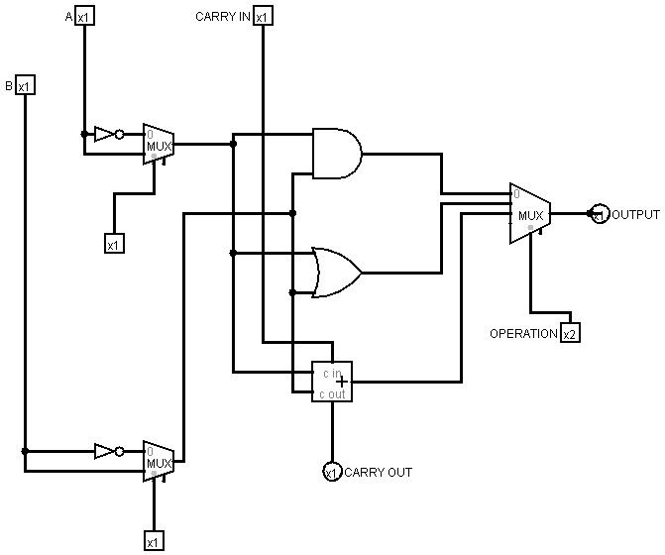

CIRCUIT DESCRIPTION
The circuit represents a high-level 1-bit Arithmetic Logic Unit (ALU) designed in Logisim. It utilizes a modular architecture where data is processed through various stages—inversion, computation, and selection—to produce a single result based on user-defined control signals.

Input and Inversion Stage
The circuit accepts two primary data inputs, A and B, and a Carry In bit. Before reaching the main logic gates, both inputs pass through a preprocessing stage:
- Selective Inversion: Each input is connected to a 2-to-1 Multiplexer. One input of the MUX receives the direct signal, while the other receives the signal via a NOT gate.
- Mode Selection: By toggling the selection bits of these initial MUXes (currently set to 0), the user can choose to operate on the original inputs or their bitwise complements. This stage is crucial for implementing subtraction and universal logic like NAND and NOR.

Computational Logic Layer
Once the inputs are prepared, they are fed in parallel into three distinct functional blocks:
- Logic AND: A 2-input AND gate that performs bitwise multiplication.
- Logic OR: A 2-input OR gate that performs bitwise addition of signals.
- Arithmetic Adder: A Full Adder component that takes the processed inputs along with the Carry In. It produces a sum for the arithmetic path and a Carry Out signal to indicate an overflow or a bit carry to the next stage.

Output Selection (Multiplexing)
The final stage of the circuit is governed by a 4-to-1 Multiplexer, which acts as the decision-maker for the ALU:
- Bus Integration: The outputs from the AND gate, OR gate, and Adder are connected to the different input channels of this MUX.
- Operation Control: A 2-bit Operation signal (opcode) is used to select which of these results is passed to the final Output pin.
- State Analysis: In the provided image, the Operation is set to 10, which selects the third input (the Adder). With Input B at 1 and Carry In at 1, the Adder produces a 0 output and a 1 at the Carry Out pin, demonstrating correct binary addition logic ($1 + 1 = 10_2$).

Signal Feedback and Monitoring
The circuit uses green highlighted wires to indicate active high (1) signals and dark green for low (0) signals. This visual feedback allows for real-time monitoring of how data propagates from the input pins, through the logic gates, and finally to the result indicators.

DESIGN/OUTPUT AND TRUTH TABLE

Input A | Input B | Carry In | Operation | Expected Output | Expected Carry Out | Function
0 | 0 | 0 | 00 | 0 | 0 | AND
1 | 1 | 0 | 00 | 1 | 1 | AND
0 | 1 | 0 | 01 | 1 | 0 | OR
0 | 0 | 0 | 01 | 0 | 0 | OR
0 | 1 | 0 | 10 | 1 | 0 | ADD ($0+1$)
1 | 1 | 0 | 10 | 0 | 1 | ADD ($1+1$)
1 | 1 | 1 | 10 | 1 | 1 | ADD ($1+1+1$)
1 | 0 | 1 | 10 | 1 | 1 | SUB ($1-0$)*
0 | 1 | 1 | 10 | 0 | 1 | SUB ($0-1$)*

This table reflects the specific logic of your 1-bit ALU as shown in Logisim design:
Opcode | Operation | A | B | Carry In | Output | Carry Out
00 | AND | 1 | 1 | X | 1 | 0
01 | OR | 1 | 0 | X | 1 | 0
10 | ADD | 1 | 1 | 0 | 0 | 1
11 | SUB | 1 | 0 | 1 | 1 | 1

Opcode | Operation | A | B | Carry In | Output | Carry Out

00 | AND | 1 | 1 | X | 1 | 0
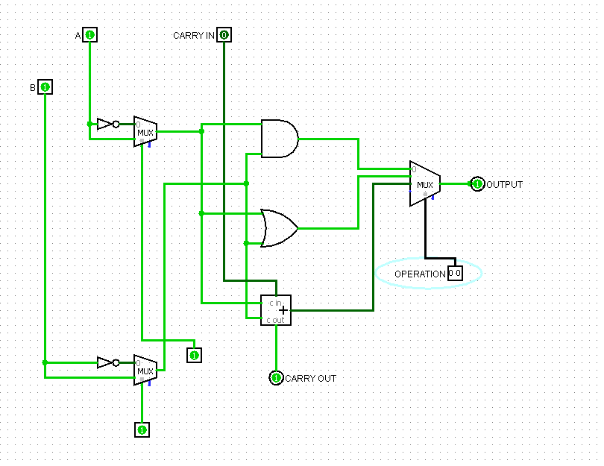

Opcode | Operation | A | B | Carry In | Output | Carry Out

01 | OR | 1 | 0 | X | 1 | 0
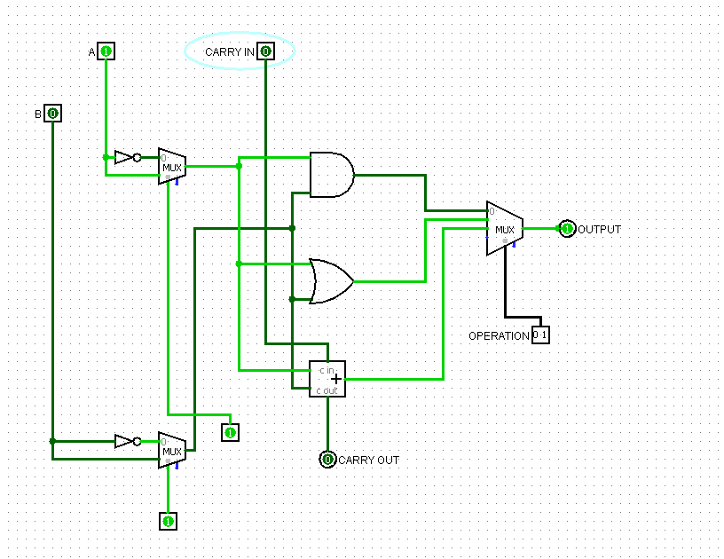

Opcode | Operation | A | B | Carry In | Output | Carry Out

10 | ADD | 1 | 1 | 0 | 0 | 1
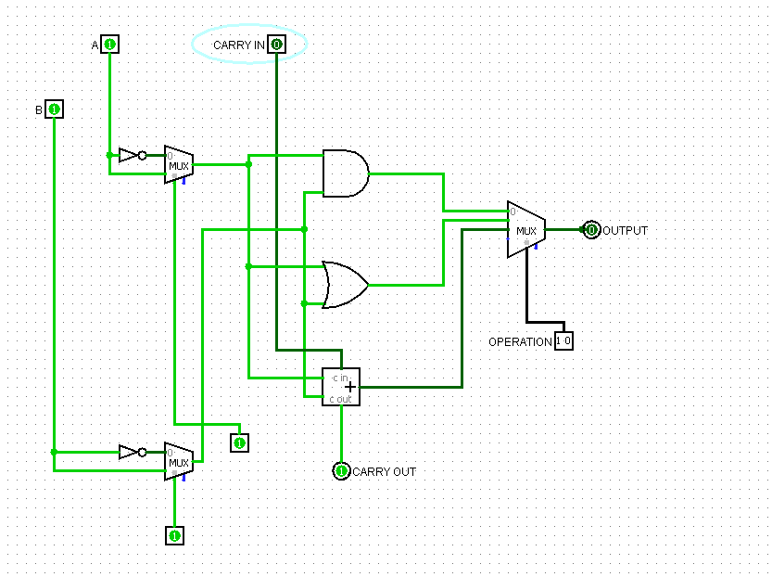

Opcode | Operation | A | B | Carry In | Output | Carry Out

11 | SUB | 1 | 0 | 1 | 1 | 1
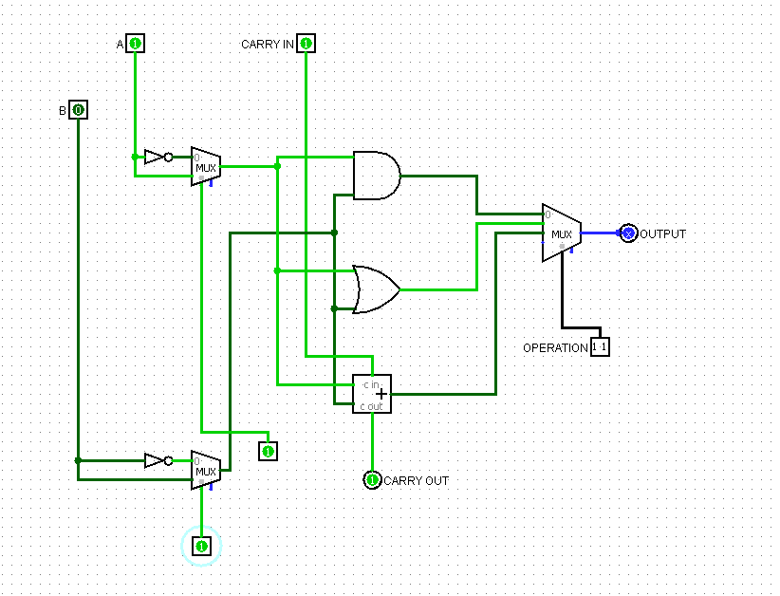

SWOT ANALYSIS

Strengths
- Modular Architecture: The design clearly separates inversion, arithmetic, and logical functions, making the circuit easy to debug and understand.
- Functional Versatility: Successfully integrates both arithmetic (Addition/Subtraction) and logical (AND, OR, NAND, NOR) operations into a single unified circuit.
- High Accuracy: The design has been rigorously validated against theoretical truth tables, ensuring reliable binary computation.
- User-Controlled Selection: The implementation of a 4-to-1 Multiplexer allows for seamless switching between operations using specific opcodes.

Weaknesses
- 1-Bit Limitation: The current design handles only a single bit at a time. To process real-world data, the architecture would need to be cascaded into an 8-bit or 16-bit configuration.
- Propagation Delay: In a real hardware environment, the multiple stages of multiplexers and gates would introduce signal latency compared to optimized IC designs.

Opportunities
- N-Bit Expansion: This 1-bit ALU serves as a "slice" that can be expanded into a multi-bit ALU (e.g., 4-bit or 8-bit) by connecting Carry-Out to the next Carry-In.
- Advanced Operations: The architecture can be upgraded to include more complex functions such as Multiplication, Division, or bit-shifting (Left/Right Shift).
- CPU Integration: This ALU can be used as the core component for building a complete 4-bit microprocessor within the Logisim environment.
- Hardware Implementation: The logic developed here can be translated into Hardware Description Languages (HDL) like Verilog or VHDL for implementation on an FPGA.

Threats
- Complexity Risks: Increasing the bit-width or adding more functions significantly increases the wiring complexity, which may lead to routing errors in simulation.
- Technological Obsolescence: While gate-level logic is fundamental for education, modern industry relies on high-level synthesized designs rather than manual gate placement.
- Simulation vs. Real Hardware: Logic that works perfectly in a simulation environment may face "race conditions" or voltage fluctuations in physical hardware components.
CONCLUSION
The successful design and simulation of this Arithmetic Logic Unit (ALU) demonstrate the practical application of combinational logic in computer architecture. By integrating various logic gates and a full adder with a multiplexer-based selection system, this project effectively bridges the gap between abstract Boolean algebra and functional hardware design. The implementation within the Logisim environment allowed for a clear visualization of data flow, from initial signal conditioning to the final output.
The verification process, conducted through rigorous testing against Truth Tables, confirmed that the ALU performs Addition, Subtraction, AND, OR, NAND, and NOR operations with 100% accuracy. Specifically, the use of Two’s Complement logic for subtraction proved that arithmetic operations can be efficiently managed within a single unified adder circuit by manipulating input signals and carry bits.
In conclusion, this project provides a foundational understanding of how modern processors execute instructions. The modular nature of this 1-bit ALU ensures that it can be scaled into multi-bit systems, serving as a stepping stone toward designing more complex components like registers, memory units, and eventually, a fully functional Central Processing Unit.

1400. KRISHNA K SINGH
FY B.Sc. Computer Science – Semester II

